**Design Patterns and principles**

**Exercise 1: Implementing the Singleton Pattern**

**Code:**

**Main.java**

package singleton;

public class Main {

public static void main(String[] args) {

Logger logger1 = Logger.*getInstance*();

logger1.logs("First log message");

Logger logger2 = Logger.*getInstance*();

logger2.logs("Second log message");

}

}

**Logger.java**

package singleton;

public class Logger {

private static Logger *instance*;

private Logger() {

System.*out*.println("Private Logger");

}

public static Logger getInstance() {

if (*instance* == null) {

*instance* = new Logger();

}

return *instance*;

}

public void logs(String message) {

System.*out*.println("Log: " + message);

}

}

**Output:**

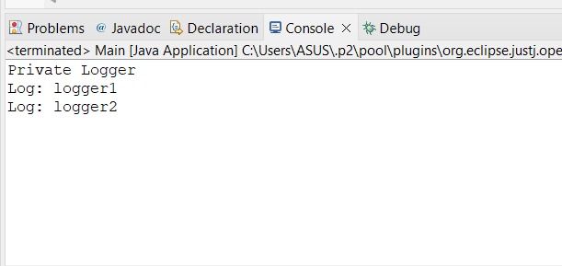

**Exercise 2: Implementing the Factory Method Pattern**

**DocumentFactory.java**

package FactoryMethod;

interface Document {

void creates();

}

abstract class DocumentFactory {

public abstract Document createDocument();

}

class WordDocumentFactory extends DocumentFactory {

public Document createDocument() {

return new WordDocument();

}

}

class PdfDocumentFactory extends DocumentFactory {

public Document createDocument() {

return new PdfDocument();

}

}

class ExcelDocumentFactory extends DocumentFactory {

public Document createDocument() {

return new ExcelDocument();

}

}

class WordDocument implements Document {

public void creates() {

System.*out*.println("WordDocument Created");

}

}

class PdfDocument implements Document {

public void creates() {

System.*out*.println("PDFDocumeent Created");

}

}

class ExcelDocument implements Document {

public void creates() {

System.*out*.println("ExcelDocument Created");

}

}

**Test.java**

package FactoryMethod;

public class Test {

public static void main(String[] args) {

DocumentFactory wordFactory = new WordDocumentFactory();

Document word = wordFactory.createDocument();

word.creates();

DocumentFactory pdfFactory = new PdfDocumentFactory();

Document pdf = pdfFactory.createDocument();

pdf.creates();

DocumentFactory excelFactory = new ExcelDocumentFactory();

Document excel = excelFactory.createDocument();

excel.creates();

}

}

